Portfolio

## Technical Communication Projects

### HTML & CSS Website

The following link is to an HTML and CSS website that was created for a Digital Technologies class in which my pets are raising money for animal shelters.

[Luessen Fundraising](https://mickeylue.github.io/Luessen-Fundraising/)

### Technical Communication: A History

How a Profession was Established

Technical communication is the sharing of information about how things work. This is a brief look at technical communication over time.

[Technical Communication: A History](https://1drv.ms/p/s!AlhfPEMnS6ZChRnfvOgAT9GzisX9?e=emi5ca)

## Research Projects

### Red River Valley Psychology Conference, 2008

A poster presentation from the 2008 Red River Valley Psychology Conference.

[Attraction & Repulsion Poster, 2008](https://1drv.ms/b/s!AlhfPEMnS6ZClFzaj4Dvm-6JAWQF?e=8jscfd)

### Red River Valley Psychology Conference, 2008

A paper presentation from the 2008 Red River Valley Psychology Conference.

[Attraction & Repulsion Paper, 2008](https://1drv.ms/b/s!AlhfPEMnS6ZCk23zkxtRd3J8AQqx?e=fVVzrO)

## Art Projects

### Acrylic Painting

This cat and dog watching sunset in a wagon painting is acrylic on canvas.

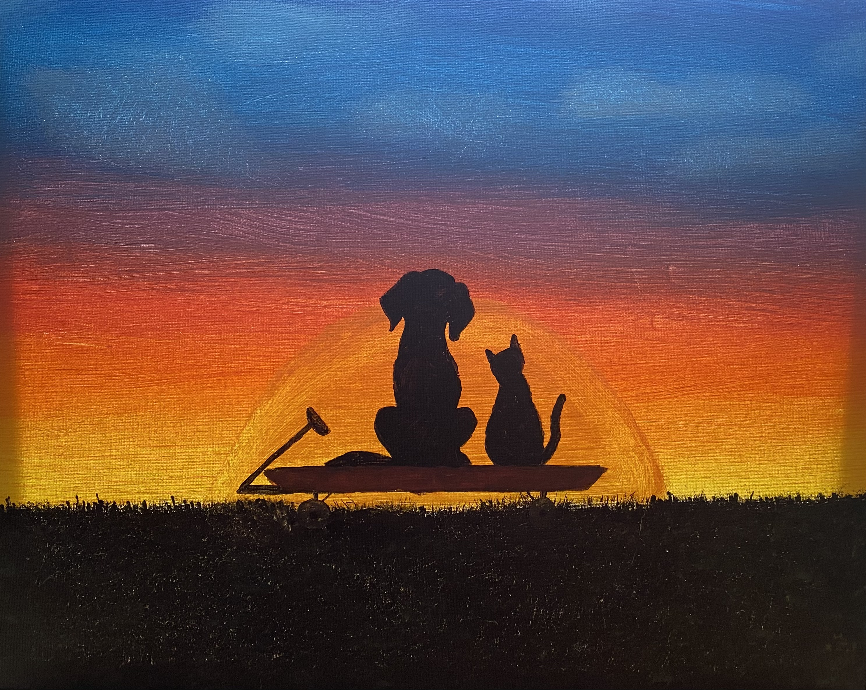

Acrylic Pet Painting

### Cricut Layered Shadowbox

This shadowbox image of the northern lights from the forest is a Cricut creation using layered cardstock.

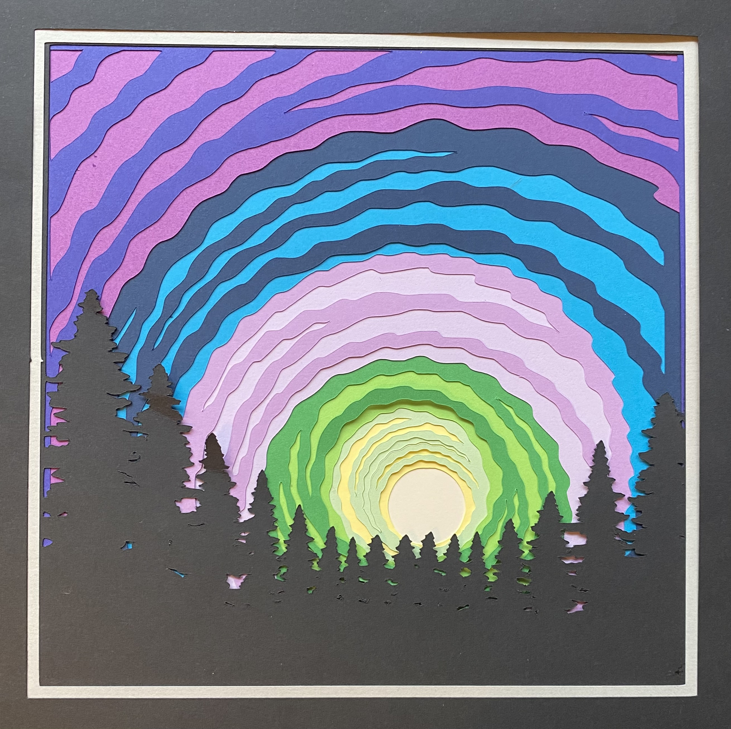

Cricut Northern Lights Shadow Box